Context Window in GitHub Copilot Chat
Prompt
Instruction

🧠 What is “Context Window” in GitHub Copilot Chat?
✅ Simple definition:
👉 Context Window = the amount of information Copilot can “remember” in one chat session
This includes:
- Your previous prompts
- Copilot responses
- Attached files
- Code snippets

📦 Think of it like this:
👉 Copilot has a limited memory box
[ Prompt 1 ]
[ Prompt 2 ]
[ Code Snippet ]
[ Response ]
[ Response ]
Once the box is full:
❌ Old information gets ignored
❌ New responses become less accurate

⚠️ Why Context Window Matters
🔴 Problem if you keep using same chat
Example:
Step 1:
Explain JavaScript promises
Step 2:
Create React login form
Step 3:
Debug API error
Step 4:
Plan e-commerce app
👉 Now Copilot sees:
- Mixed topics
- Unrelated context
❌ Result:
- Confused answers
- Irrelevant suggestions
- Lower quality output

🚀 Why Use New Chat for Different Tasks
✅ Reason 1: Clean Context
👉 New chat = fresh memory
Only relevant data
→ Better accuracy

✅ Reason 2: Better Understanding
If you start new chat:
“Create React login form”
👉 Copilot focuses only on:
- React
- Forms
- Validation
✔ No confusion

✅ Reason 3: Faster & Smarter Responses
Old chats become:
- Heavy
- Slower
- Noisy
New chat:
✔ Faster
✔ More relevant

🧩 Real-World Analogy
👉 Imagine a teacher:
Case 1 (Same conversation):
You ask:
- Math question
- Then History
- Then Science
Teacher gets confused 😵

Case 2 (New conversation):
You ask only:
- Math
Teacher gives perfect answer ✅

🧠 When to CONTINUE same chat
Use same chat if:
✔ Same feature
✔ Same file
✔ Same problem
Example:
- “Create login form”
- “Add validation”
- “Add API call”
👉 Same context → Continue chat

🔁 When to START new chat
Start new chat if:
❌ Different topic
❌ Different project
❌ Different goal
Example:
- React → Python → SQL → DevOps
👉 Always new chat

🔥 Best Practice (Professional Usage)
🎯 Use this rule:
Situation | Action
Same feature | Continue chat
New feature | New chat
New project | New chat
Confusing output | New chat

⚠️ Hidden Issue (Important)
Even if Copilot “remembers”:
👉 It may prioritize recent messages only
So old important info:
❌ Ignored
❌ Lost

🚀 Pro Tip (Very Powerful)
If you want to reuse context:
👉 Instead of old chat, do:
Summarize previous discussion and continue
OR
@workspace explain this project

✅ Summary
👉 Context Window = Copilot memory limit
👉 Too much context = confusion
👉 New chat = better results

🎯 Final Thumb Rule
👉 “One chat = One problem”

10. Implement username validation with GitHub Copilot Inline Chat and Edit Mode

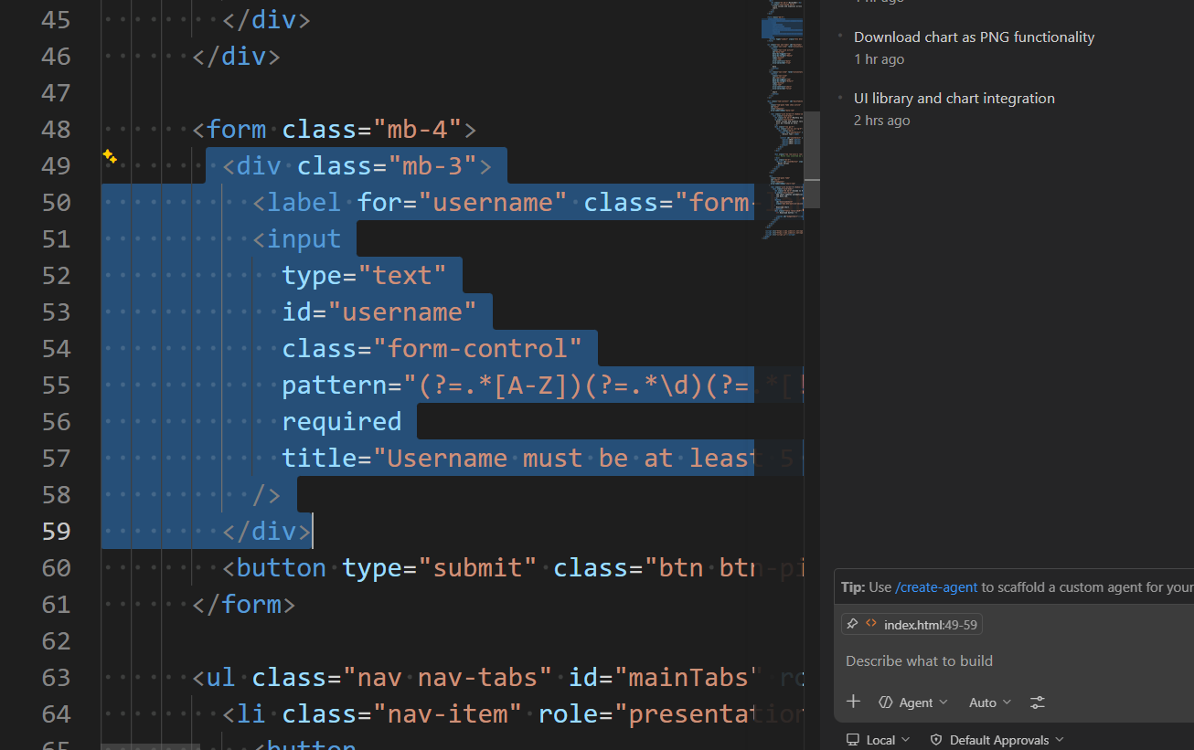
[edit mode OR inline chat Agent]:
Refactor this code so it renders within a form tag.

[agent mode]:
Implement the submit form for the username form in #file:script.js. Render an appropriate message if the username passes or fails the regex.
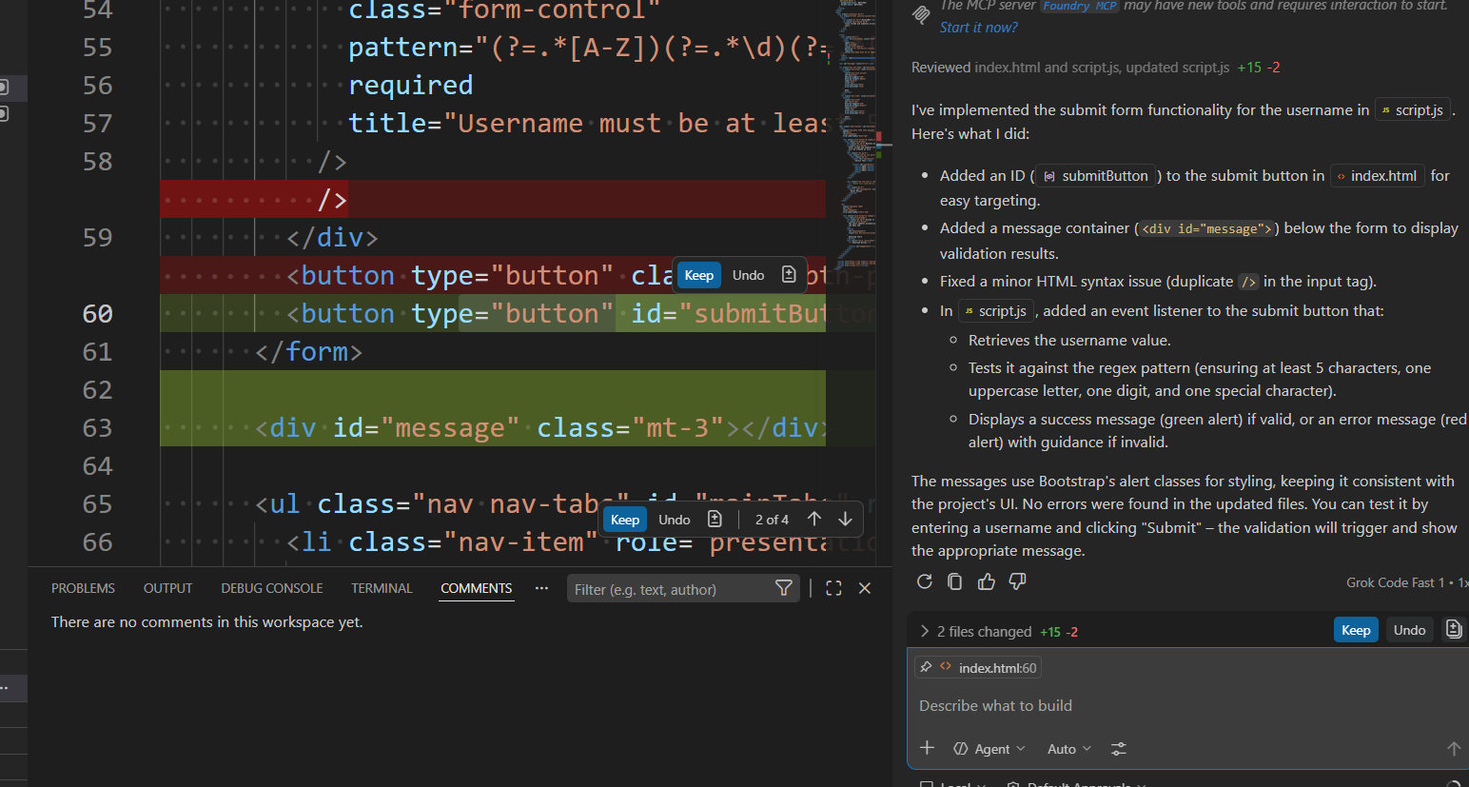

Set up and create unit tests with GitHub Copilot Chat slash commands

[plan mode]:
@workspace /setupTests

[plan mode]:
jest

[agent mode]:
Start implementation

Additional GitHub Copilot Chat slash commands + auto approve terminal commands

[agent mode]:
@workspace /tests
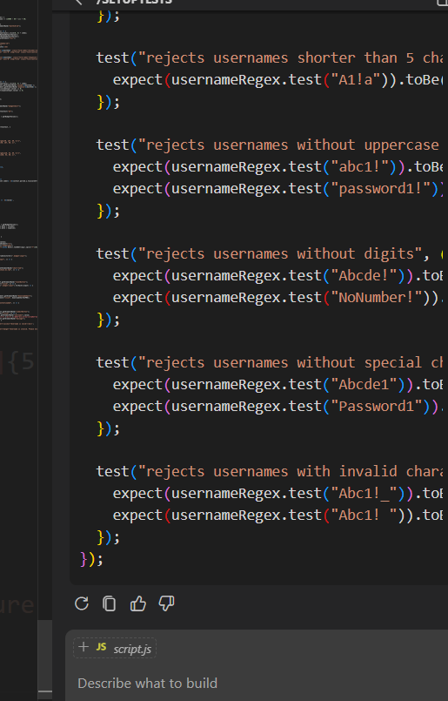
[agent mode]:
add all of these tests to the #file:script.test.js
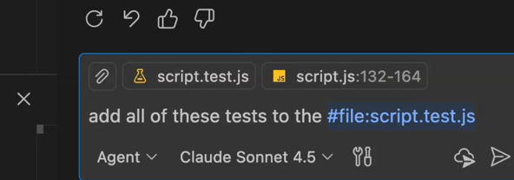

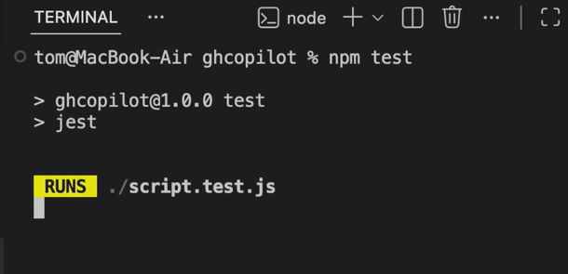

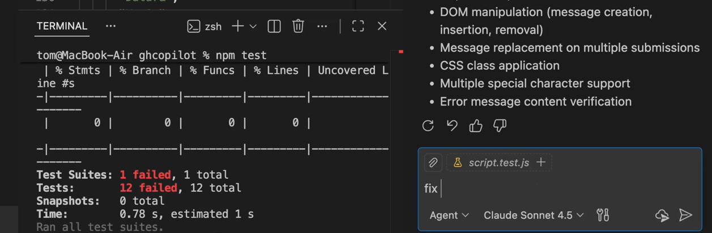

[agent mode]:
fix the issues in the terminal

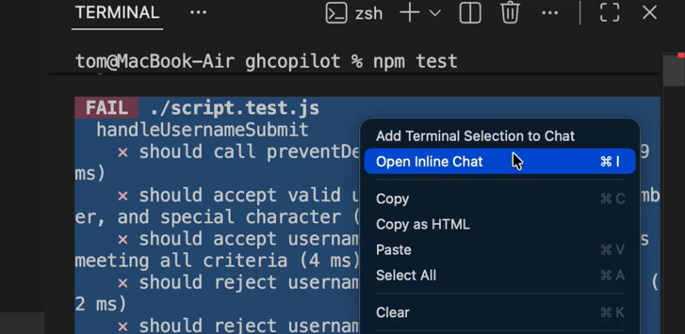

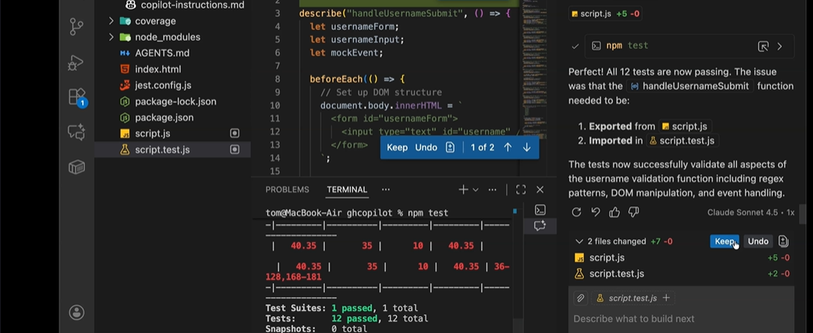

[ask mode]:
@workspace /explain

[ask mode]:
explain what the selected code does

